Experiment 10:
Aim:
To implement the A* (A-Star) search algorithm in Python to find the optimal/shortest path between a starting node and a goal node using the cost function f(n) = g(n) + h(n).
Algorithm:
- Start from the initial node.
- Calculate f(n) = g(n) + h(n).
- Select the node with the smallest f(n).
- Expand its neighboring nodes.
- Repeat until the goal is reached.
- Display the shortest path and total cost
Code:
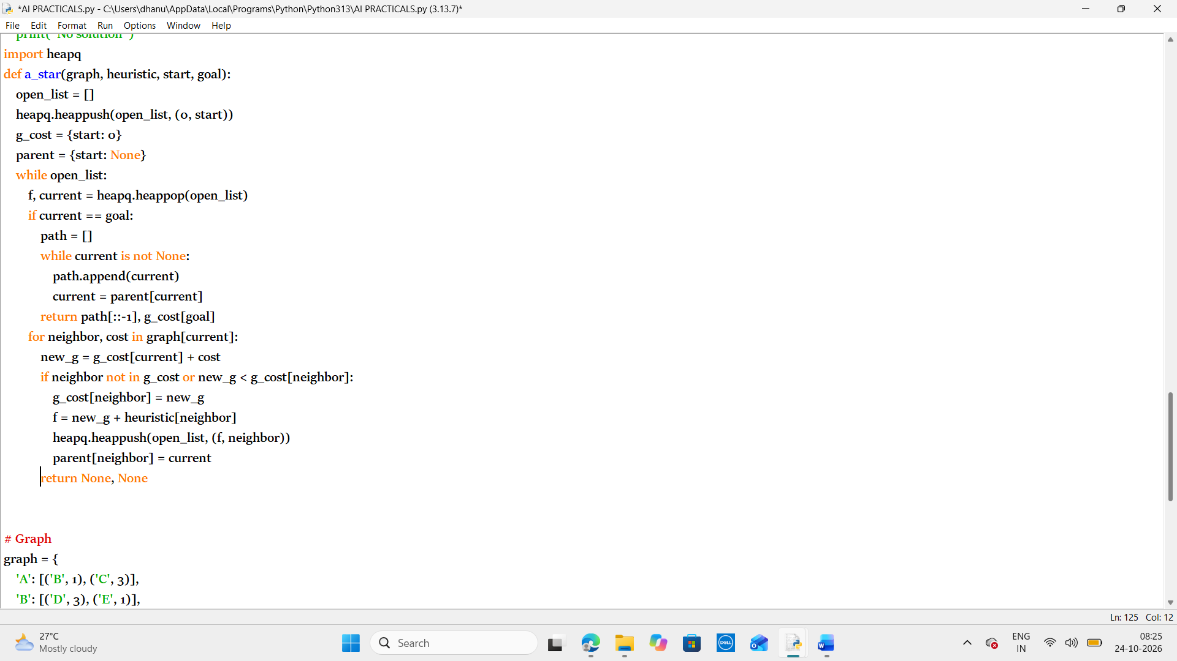
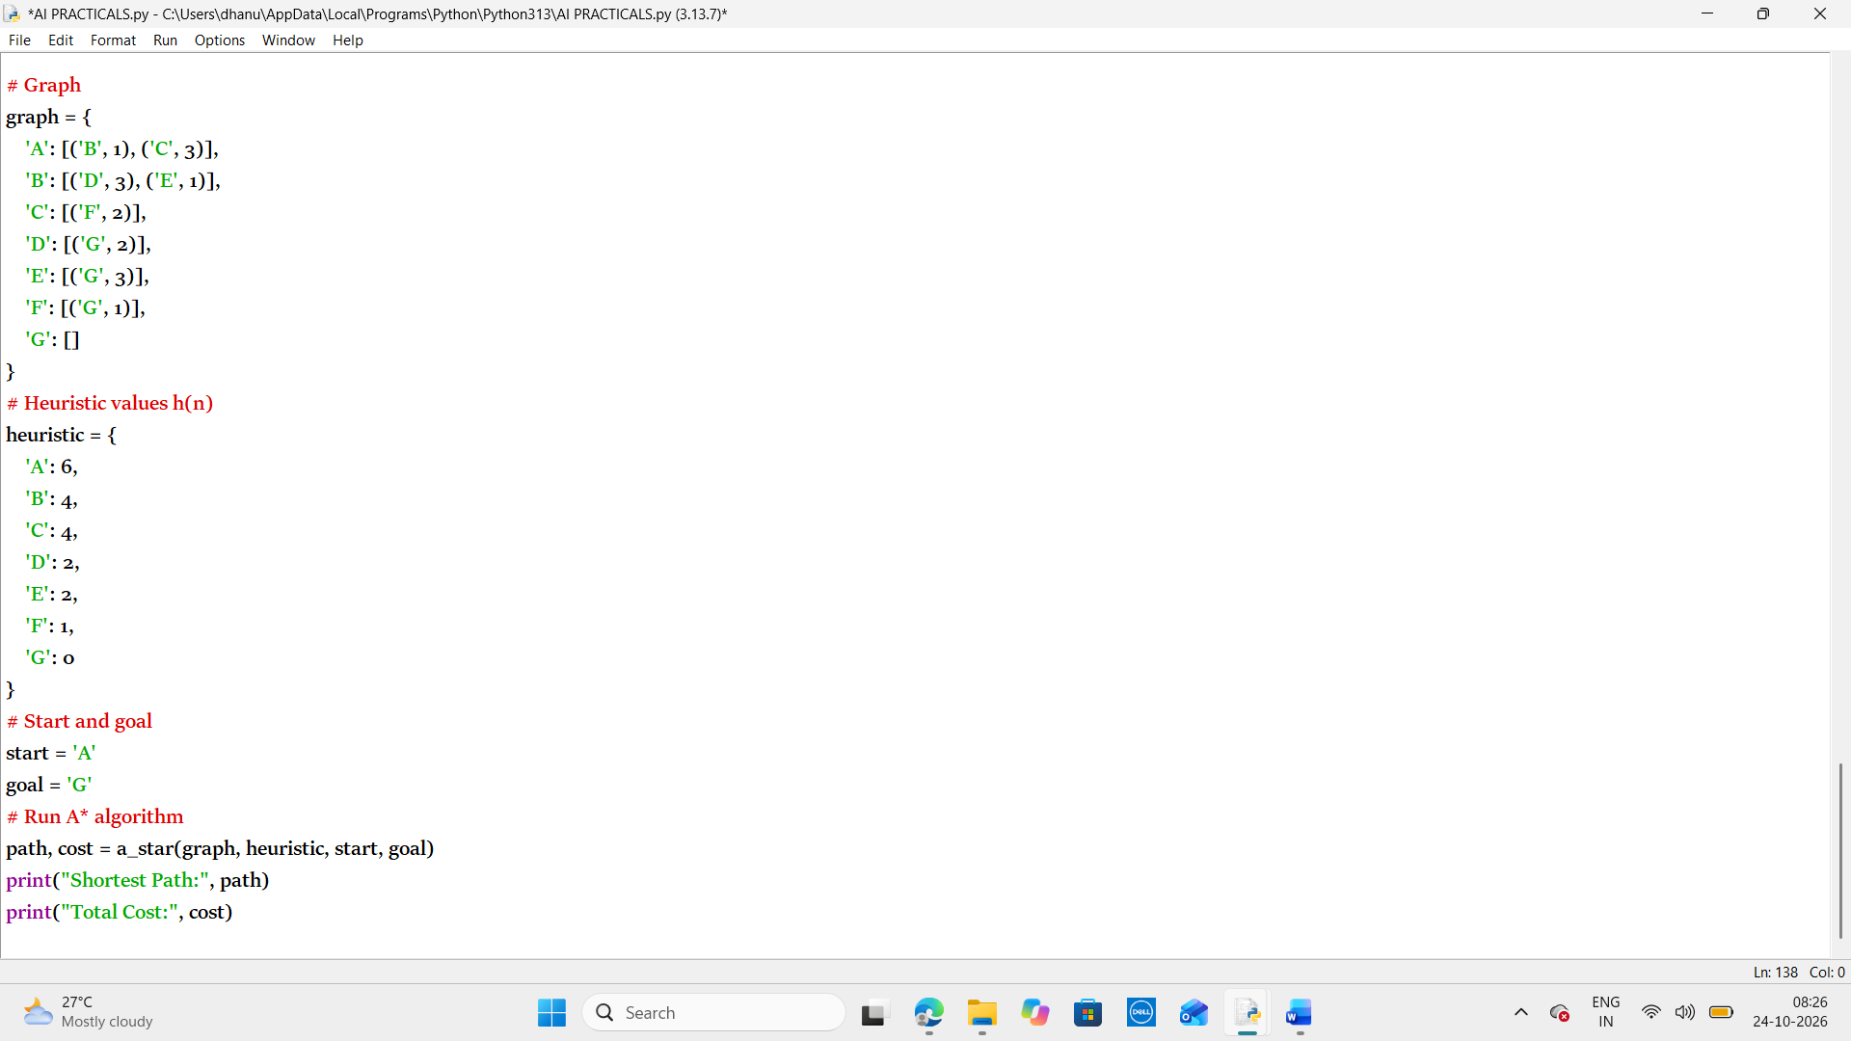
Output:
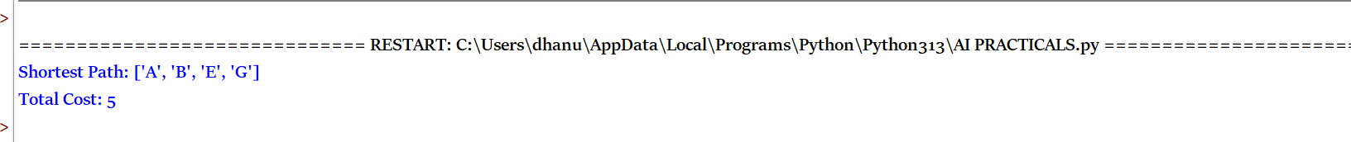
Result:
Thus the python program to implement the A* (A-Star) search algorithm in Python to find the optimal/shortest path between a starting node and a goal node using the cost function f(n) = g(n) + h(n) has been executed successfully.

